**Summary of CFC Changes to GIS**

The Customer Facility Charge (CFC) is a fee imposed by YVR Airport. It is $5 per day, and up to a maximum of $35 or in other words, 7 days.

**NOTE:** Foreign rental check Ins do not charge CFC (unless the Checking Out location charges CFC).

**Tour Rental:**

Some tour rates will include CFC in the rate.

Example: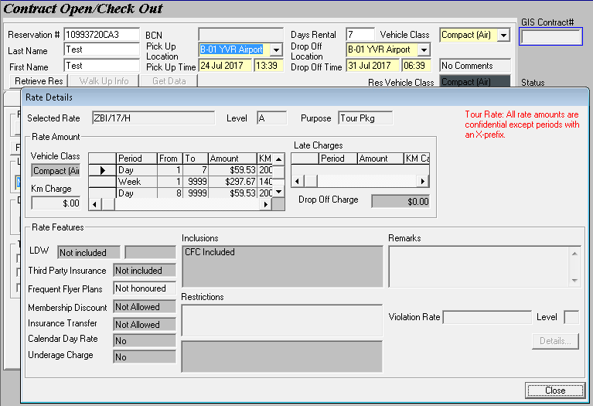

**NOTE:** CFC will not be shown in the Rental Charge Billing on its own in this case because it is already included in the Vehicle Rental amount.

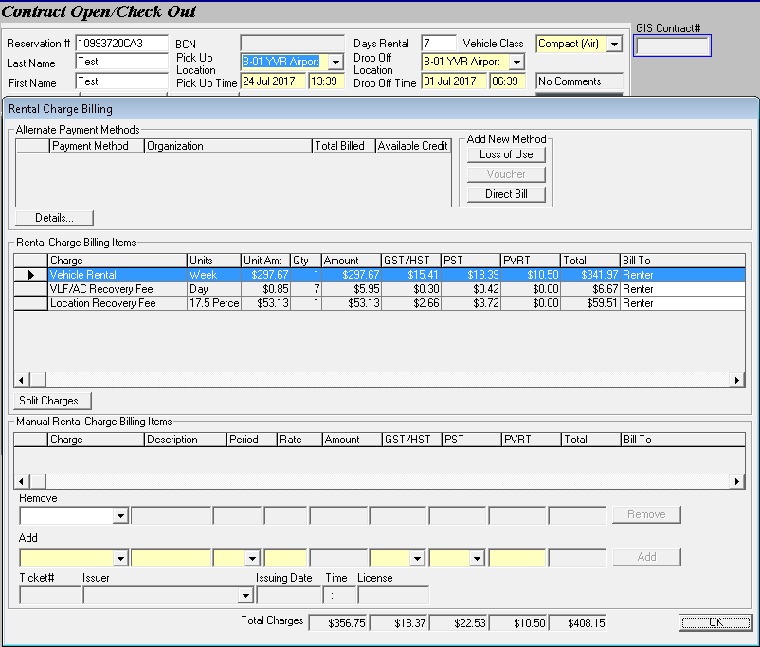

Which also means CFC is included in prepaid vouchers.

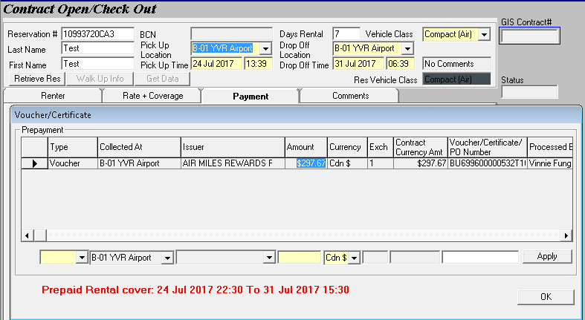

CFC is not shown in GIS but is still collected and reflected in the Sales Journal at Check In. 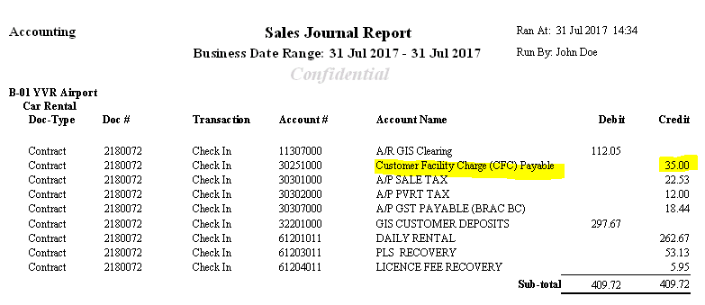

**Non-Tour rental:**

Some rates do not include CFC.

Example:

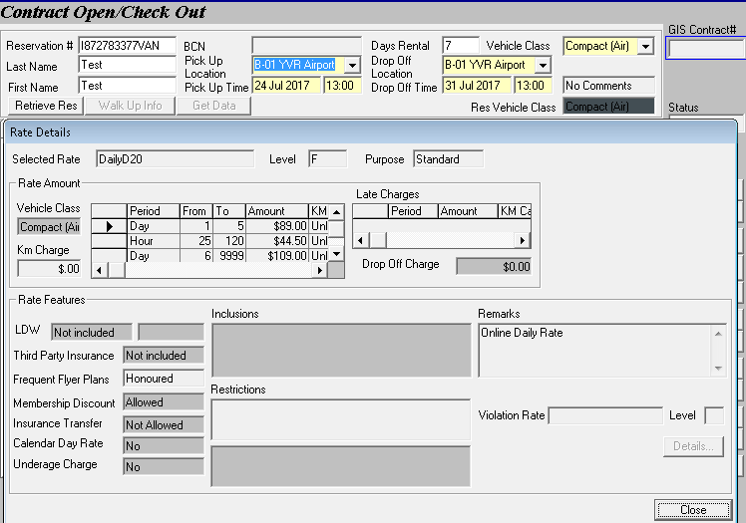

In this case, CFC shows separately from the vehicle rental because it is not included.

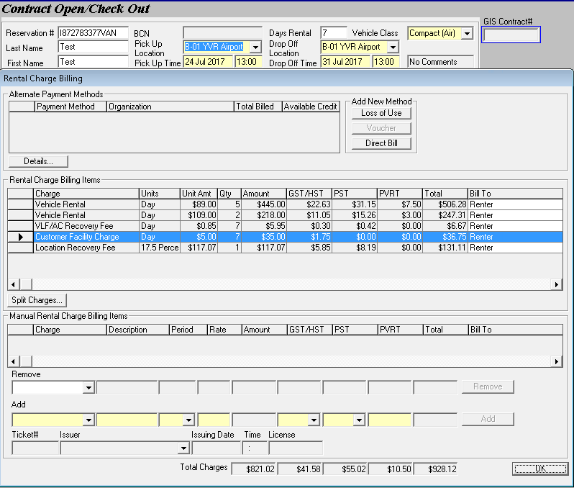

CFC is shown separately in the Sales Journal.

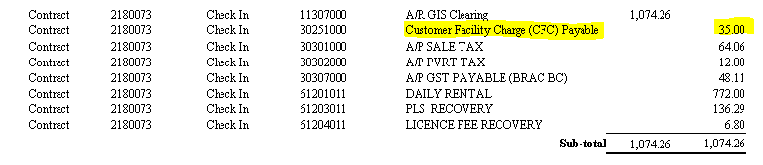

**Rental Extension:**

When a contract with CFC (either included or not included in the rate) is extended, only the first 7 days including the original length of rental are CFC-able. In the case of prepaid vouchers, if the contract is 5 days and was extended for 3 days, with 8 days total. The voucher only covers the originally agreed upon amount of days, so the 2 extra days’ CFC will be charged to the renter while the 5 days’ CFC is covered by the voucher. The 1 extra day of the 3 extra days is not charged CFC because CFC is limited to only the first 7 days of the rental.